**Smart Bridge Cognito userpool migration Plan**

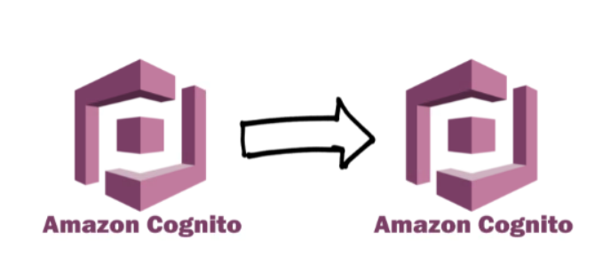

The User Migration trigger executes a Lambda function whenever a user isn’t found in the User Pool during login (or password recovery). The Lambda function must return if the user is legit, and if so, Cognito will automatically create the user in the new User Pool.

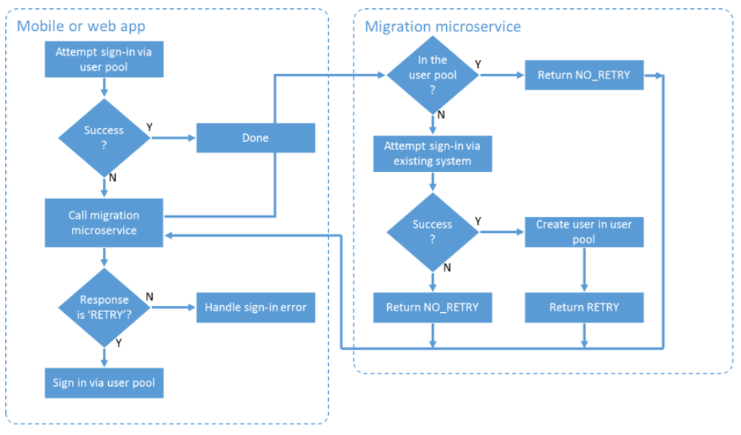

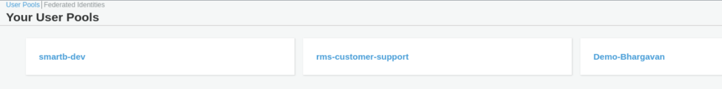

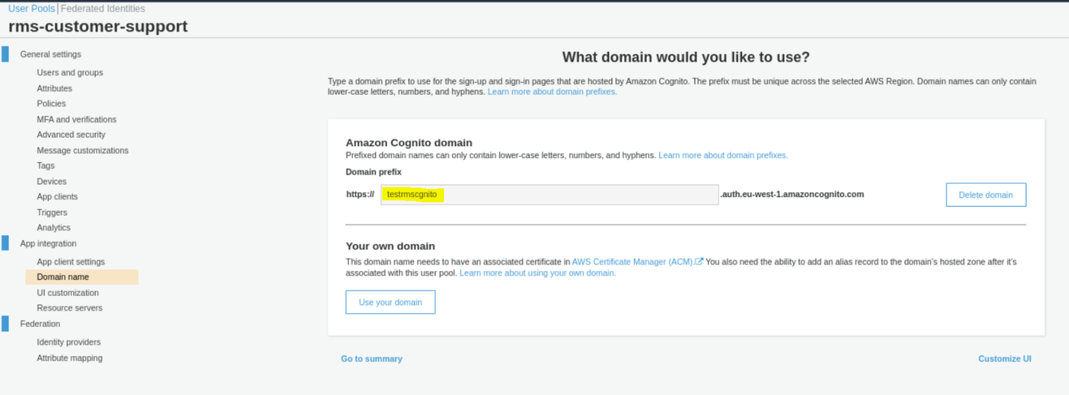

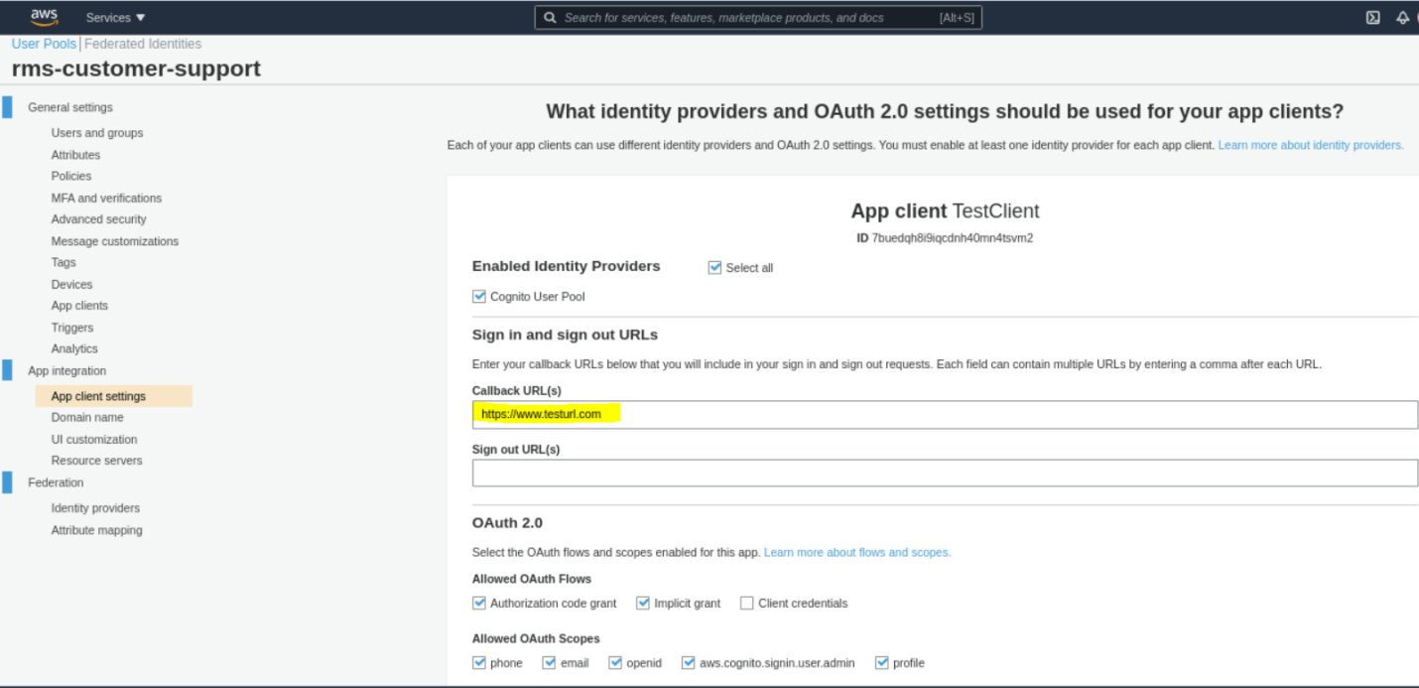

https://testrmscgnito.auth.eu-west-1.amazoncognito.com/login?

response_type=token&client_id=7buedqh8i9iqcdnh40mn4tsvm2&redirect_uri=https://www.testurl.com

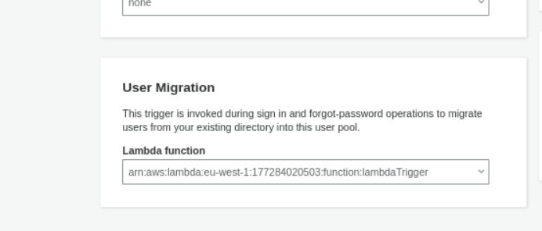

**https://github.com/bhargavan-devops/migrate-cognito-user-pool-lambda**